Open the frontend project on Firebase, go to the Hosting section and select Add custom domain

Enter the domain name and Continue

Next to have a domain, you can buy it at GoDaddy:

<https://www.godaddy.com/en-sg/offers/godaddy>

In my project, the domain was purchased in pavietnam:

<https://www.pavietnam.vn/vn/dang-ky-ten-mien.html>

After registering and purchasing the domain name, go to the configuration page and fill in the Host, Type Record, and IP Address information corresponding to the Firebase Domain Custome created above.

Add www and @ for Type Record A, @ for TXT in the Host section, then save the configuration

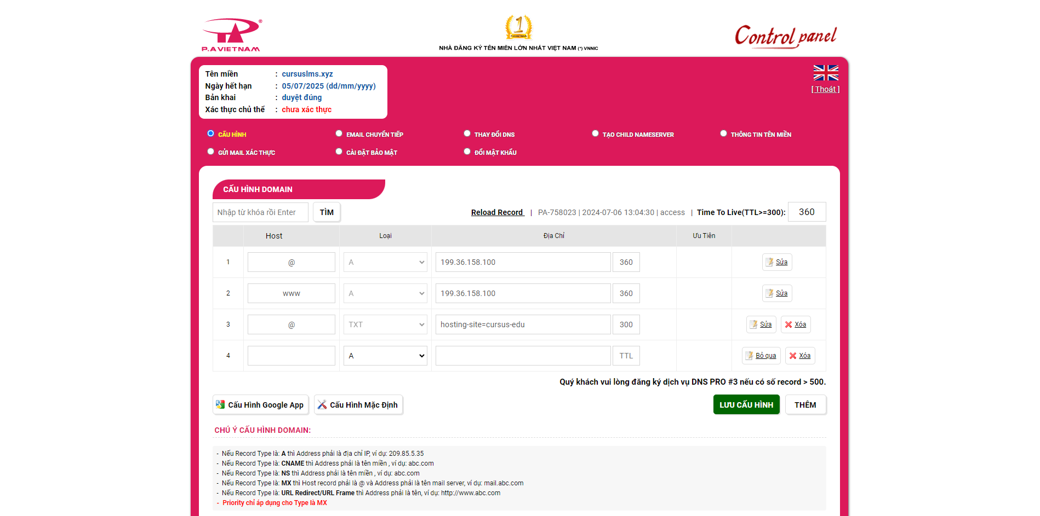

Now we will wait and there is a term called DNS Propagation

DNS propagation is commonly used to check the current status of DNS results globally and is often asked when changes made to a DNS zone do not appear to be working as expected. This process may take just a few minutes, but often takes up to 48-72 hours and sometimes longer.

You can check the domain on the website

<https://www.whatsmydns.net>

After successful global propagation, select Verify in Firebase

So the domain has been successfully customized

End!